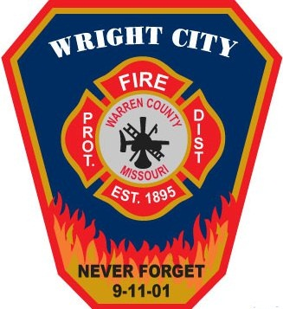
Wright City Fire Protection District
“To serve, educate, and protect our community.”

396 West North 2nd Street
Wright City, Missouri 63390
Phone (636) 745-2262
Fax (636) 745-2259
www.wrightcityfire.com
Wright City Fire Protection District
Request for Sealed Bid Proposals for Surplus Fire Apparatus/Equipment

The Wright City Fire Protection District is seeking sealed bid proposals for surplus fire Apparatus/Equipment. Please see below for more information.

OVERVIEW

- The purpose of this request for sealed bid is to solicit proposals from interested parties to provide sealed bids for surplus apparatus/equipment currently owned by the Wright City Fire Protection District. The primary objectives are:
  - To provide all members of the public with an equal opportunity to submit a proposal.
  - To provide the information necessary for preparation of proposals.
  - To provide Wright City Fire Protection District with an unbiased method of surplus property elimination.

- The intent of Wright City Fire Protection District is to select one winning bid for the advertised item.

- Wright City Fire Protection District reserves the right without prejudice to reject any or all proposals and to accept or reject any item or combination of items in any proposal. Any proposal received by Wright City Fire Protection District will be valid and binding for a period of sixty (60) days beyond the submission deadline.

- The bid awarding will take effect on or about October 10, 2019, and winners will be notified via their preferred method of communication.

- Wright City Fire Protection District will not pay for any information requested, nor is it liable for any costs incurred by the submitter in the preparation of their proposal.

- Criteria for evaluation of proposals will be:
- Completeness of the proposal.
- Submitted by the deadline and meeting all criteria.

- During the evaluation process, Wright City Fire Protection District reserves the right to request additional information or clarifications from those submitting proposals, or to allow corrections of errors or omissions. All proposals become the property of Wright City Fire Protection District and will not be returned to the submitter.

- To be considered, please provide Wright City Fire Protection District one sealed copy of the Bid Form to:

Wright City Fire Protection District
396 West North Second Street
Wright City, MO 63390

no later than posted dates respective to each item. All proposals will be evaluated and may be presented to the Board of Directors at their next regularly scheduled meeting following the submission deadline.

- Awardee is required to submit full and final payment via cashiers check or money order (no personal checks or cash will be accepted) at time of possession.

- Awardee must retrieve item no later than 10 business days after award notification. Failure to do so constitutes surrender of awarded item.

PROPOSAL Requirements

      - BID FORMS

The submitter is required to use the attached Bid Form for submission of their proposal. Copies of the Bid Form are available by contacting the Wright City Fire Protection District.

Wright City Fire Protection District
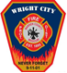
Wright City Fire Protection District
“To serve, educate, and protect our community.”

396 West North 2nd Street
Wright City, Missouri 63390
Phone (636) 745-2262
Fax (636) 745-2259
www.wrightcityfire.com
Bid Form

Surplus Apparatus/Equipment

REQUEST FOR SEALED BIDS
1995 Rescue Truck

Minimum Bid of $50,000

For additional information, or to schedule viewing of the equipment, please contact:

Assistant Fire Chief Josh Riebe
(636) 745-2262

Bid Closing Date/Time: October 9, 2019 at 12:00 p.m. Local Time.
Bid Award: On or about October 10, 2019.

Bid: $

Name:

Address:

Telephone Number:

Email Address:

Preferred Method of Contact:



